Escaux UCS interoperability with IMS Orange Belgium

Document Control
Version | Date | Notes
0.1 | 08/07/2014 | First draft
1.0 | 11/07/2014 | Review by Dominique Bogaerts (Escaux)
1.1 | 08/12/2014 | ESCAUX SIP Trunk settings Updated by Bogaerts (ESCAUX)
1.2 | 26/09/2015 | Add some information to be more explicit about outgoing call format
1.3 | 02/01/2017 | Review some cosmetics details

Acronyms
DDI : Direct Dial In number
IMS : IP Multimedia Subsystem
LAN : Local Area Network
SDP: Session Description Protocol
SIP: Session Initiation Protocol
UCS: Unified Communication Solution

References
 | Title | Version
1 | Escaux Administration Guide: Unified Communication Solution 4.10.  https://www.escaux.com/docs/SmpAdminGuide4d10.html | 2.2

Introduction
The purpose of this document is to provide configuration guidelines for connecting the Unified Communication Solution of Escaux (UCS) to the Orange Belgium IMS infrastructure.
The document does not deal with IP Telephony LAN design. More details are available in [1].

Definition:
Inbound call: call from IMS to UCS
Outbound call: call from UCS to IMS
IMS SIP Trunk: the SIP trunk between the UCS and the IMS

UCS Environment
The purpose of this section is to quickly describe the architecture of Escaux UCS. The UCS is made of Service Operational Points (SOPs) and a Service Management Point (SMP).
The realtime tasks are executed by SOPs. These are appliances that can be installed on-site for connectivity in order to be close to the users. The SOPs can also be installed remotely, as long as the phones and applications can reach them over a network.
Non-realtime tasks are split off in a centralized web interface: the SMP.

Software release
The software release of the UCS is 4.10

Solution Design
This chapter defines the different view of the Solution Design

IMS & ACCESS Infrastructure

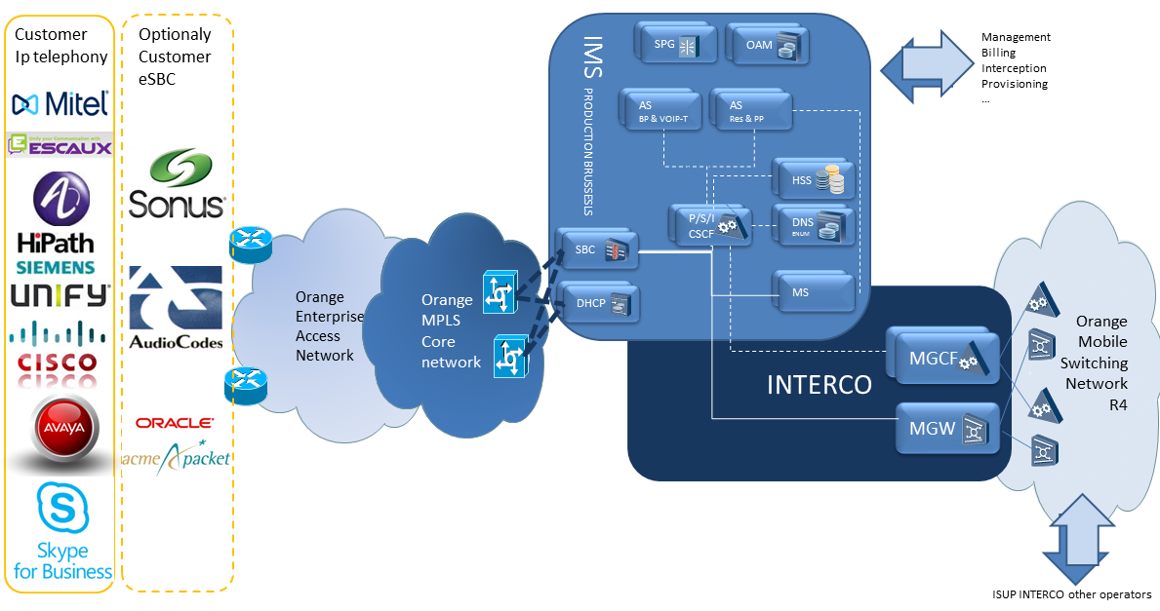
Figure : IMS and access architecture

The Orange Belgium IMS Core & access network is composed with composed with different domains
The Access network enable to deliver a IPVPN over multi access technology (Fiber, DSL,…)
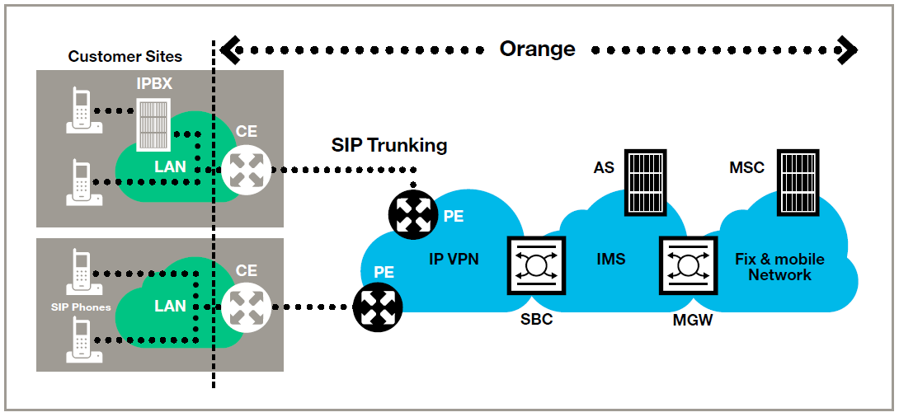
Figure : Access architecture
  - Solution for business continuity
Various solution could be minded, most typical are

- IP access redundancy (IP Access Redundancy)
- IP access redundancy + Escaux UCS redundancy
- Redundancy via VoIP enterprise Trunking
- ISDN GW backup into Escaux UCS

IP VPN access redundancy
Redundancy options are available for the VoIP Trunking service on IP VPN level. There are several possibilities of redundancy at IP VPN level :
- The CE at Customer site is linked via 2 different accesses to the IP VPN Network. These accesses are configured in active/standby mode and are terminating on 2 different PEs.
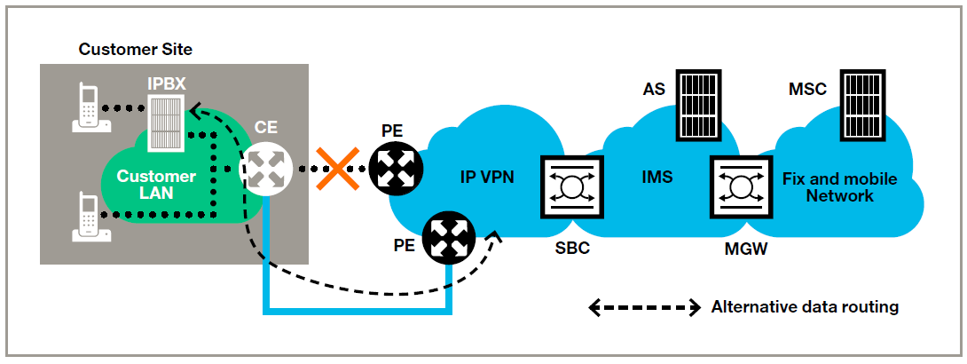

- Two CEs are installed at Customer site. Each CE has its own access to the IP VPN Network and its own terminating PE. Behind the 2 CEs, there can be 1 or 2 IPBX.
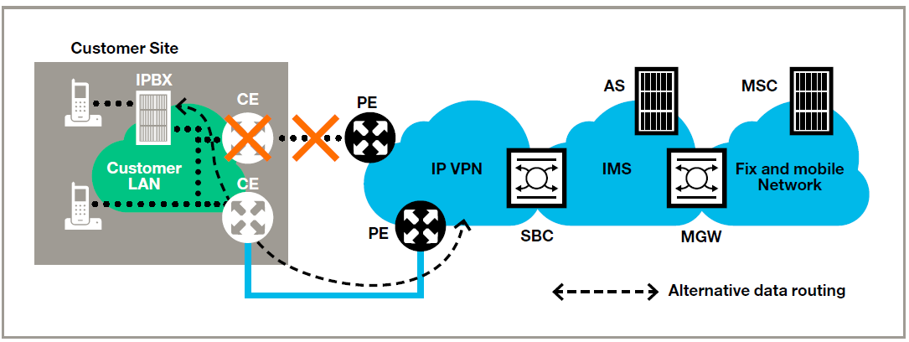

- The redundancy is managed on 2 different sites. Each Customer site has its own CE, access and terminating PE. Here also, there can be 1 or 2 IPBX in the Customer architecture.
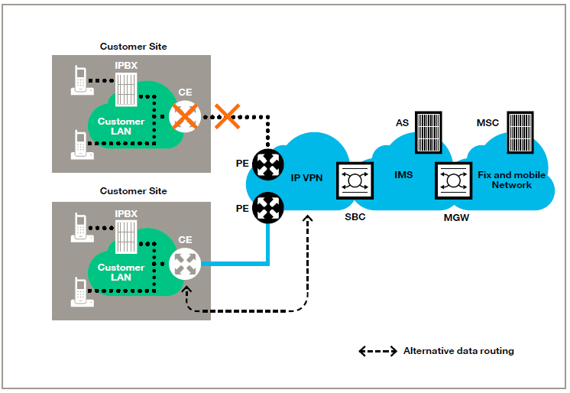

When 1 CE/access falls, the IP VPN Network transfers the traffic towards the back-up CE/access. This is transparent for Orange IMS Platform.
More info on redundancy at IP VPN level can be found in the IP VPN product description.

VoIP Back-up
Redundancy can also be managed at IMS level via the VoIP Back-up option.
When a SIP trunk or the IPBX linked to the SIP trunk is down, then all the calls (all the numbers of the trunk impacted) are automatically forwarded to a specific destination determined by the Customer at the moment of the contract :
- One specific number (mobile, fix, international)
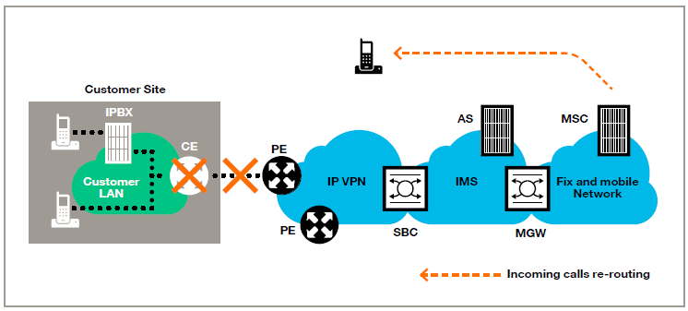
Orange IMS Platform will re-route the incoming calls towards the selected phone number.

- An Orange PRA Service
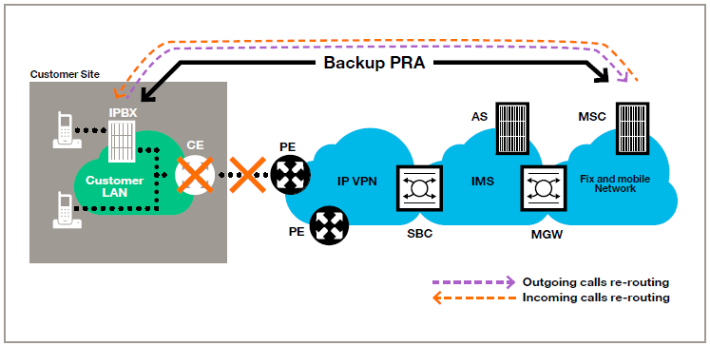
Orange IMS Platform will re-route the incoming calls towards the NDG of the backup PRA Service. The Customer IPBX will take care of the re-routing of the outgoing calls towards the backup PRA Service.

- Another SIP trunk
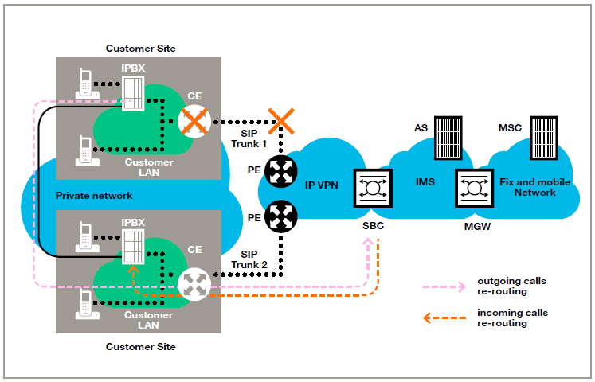
In case the calls are redirected toward another SIP trunk, most of the time the back-up SIP trunk is configured on another Customer site and is linked to another IPBX. Each SIP trunk has in this case its own NDG and is managing its own list of DDIs. There is no overlap possible between the list of DDI of the 2 different trunks (main & back-up). All DDIs must be configured on all IPBXs and the IPBXs take care of the re-routing of the outgoing calls towards the back-up SIP trunk.
In screening mode, the Customer has to know that a NDDI from the SIP trunk 1 going through SIP trunk 2 in case SIP trunk 1 is down will be seen as NDG of SIP trunk 2 on called phone.
In order to implement the VoIP Back-up option, a technical validation is always needed at Orange before the contract finalization.

Business continuity
Another way to manage the redundancy at IMS level is the business continuity option.
In case of business continuity, an Enterprise trunk will be configured. This is a virtual trunk, which contains all trunks (or in some cases, part of them) of a company. All the DDI of the Customer are configured in this case in one common pool. As usual, each trunk needs to be created/configured 1 by 1 and has his own NDG, but in this case the NDG can be a DDI of another trunk. Thanks to the common pool of DDI with 1 main NDG, in case of screening for NDDI, it enables to have a unique NDG label used.
The Enterprise trunk manages the routing between the different trunks. The different possible routing types are :
- Active / passive : In general, all traffic pass via trunk 1. When trunk 1 is not reachable, then the second trunk is used. The second trunk will also take overflow call if the first trunk is full. This logic also works with more than 2 trunks
- Load balancing : X% of the traffic goes through trunk 1, Y% via trunk 2 and Z% via trunk 3
- Determination of priorities between trunks : In priority 1, all traffic go through trunk 1. When trunk 1 is full, then traffic go through trunk 2. When trunk 2 is full, then traffic go through trunk 3,…
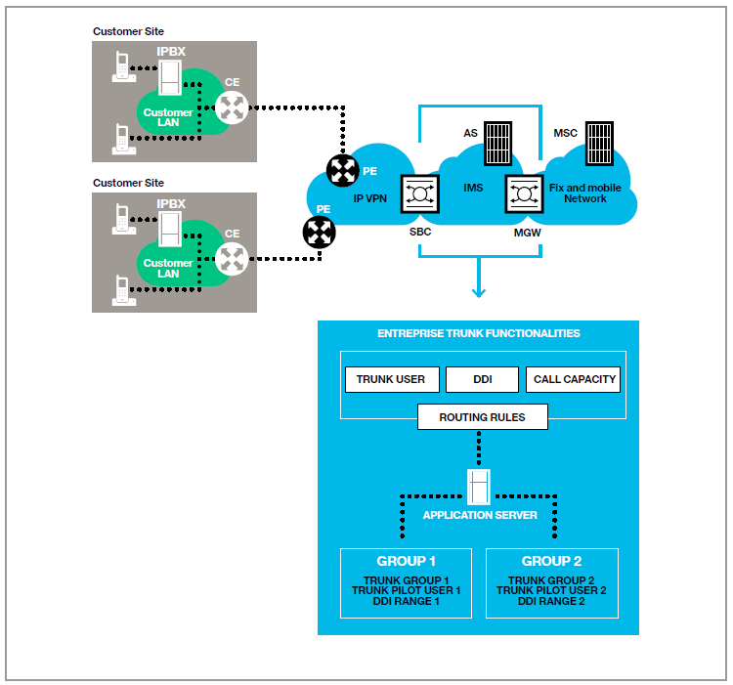
In order to implement the Business continuity option, a technical validation is always needed at Orange before the contract finalization.

- Provisioning parameters transmitted to the customer
Parameter | Value example | Format | Definition
[CORP_SITE_PBX_NDG] | +3224312490 | Tel num (8 digits) | PBX NDG or tel number of pilot number PBX (1 head number)
[CORP_ID]-[CORP_SITE_ID]-NDG@sip.mobistar.be | 040000940-040000941-NDG@sip.mobistar.be | User name | Compilation of FFCLI &FCLI
[CORP_SITE_PBX_NDS_n] | +3289550940>  +3289550947 | Tel num (8 digits) | PBX NDS ( tel number of DDI or NDS users behind PBX not including NDG)
[CORP_SITE_PBX_SIPPWD] | IMSHUAWEI | Random, with following format | SIP password for PBX
[VOIPT_CPETYPE_PUBSIG] | 212.224.148.97 | Public IP address | 1 Pub IP address per CPE Type per corporate - Client Side IP (this one is the one configured by customer in IPPBX).
[VOIPT_DOMAINNAME] | sip.mobistar.be | String | Host name part of SIP URI, SIP domain
[CORP_BACKUP] | +3289550000 | 9 digit tel number ex. 493262426 | Voice backup destination (national / international) mobile destination
[CORP_SITE_SUBNET | 192.168.50.1 | Private IP address (subnet) | Site (or corporate) subnet (main and remote)
[CORP_SITE_SUBNETMASK] | 255.255.255.0 | Private IP address (subnet mask) | Site (or corporate) subnet (main and remote)
Table : configuration parameters provided by Orange
IMPORTANT REMARK:
[CORP_ID] actually equal [FFCLI] and [ CORP_SITE_ID] equal [FCLI] so in other terms the Username = aslo [FFCLI]_[FCLI]-NDG
While of course the REGISTER is send From&To the NDG that is pilot user of the trunk
Ex: for [CORP_SITE_PBX_NDG] = +3289550100

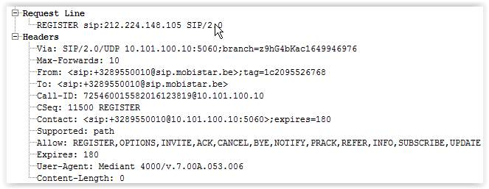

- Supported Services
The purpose of this section is to list the services offered by Escaux UCS that have been validated with the SIP trunk of Orange:
- Basic incoming and outgoing calls
- Call hold
- Call Forwarding Unconditional
- Call Forwarding on No Answer
- Call Forwarding on Busy User
- Call forwarding to PBX
- Blind Transfer
- Consultative Transfer
- Conference
- Call Waiting
- Calling Line Identity Presentation
- Calling Line Restriction
- DTMF
- Emergency calls
- Fax calls
- not generic mode
- call barring
- short numbers
- NDG presentation

- Configuration
The purpose of this section is to describe the configuration of the Escaux UCS, based on
- The parameters transmitted by Orange to the customer, as provided in section 3
- Other parameters described here.
Figure : configuration parameters inside the Enterprise

Parameter | Value example | Format | Definition
[PHONE_SUBNET] | 10.0.12.0 | IP address | Subnet of the phones
[PHONE_SUBNETMASK] | 255.255.255.0 | Subnet mask | Subnet mask of the subnet [PHONE_SUBNET]
[UCS_IP_ADDR] | 10.0.12.11 | IP address | IP address of the UCS (access side)
[MOB_SUBNET] | 192.168.50.1 | IP address | Subnet of the UCS (Orange side)
[MOB_SUBNETMASK] | 255.255.255.0 | Subnet mask | Subnet mask of the subnet [MOB_SUBNET]
[UCS_MOB_IP_ADDR] | 192.168.50.12 | IP address | IP address of the UCS (Orange side)
[MGMT_SUBNET] | 10.0.12.0 | IP address | Subnet of the UCS (Management network)
[MGMT_SUBNETMASK] | 255.255.255.0 | Subnet mask | Subnet mask of the subnet [MGMT_SUBNET]
[UCS_MGMT_IP_ADDR] | 10.0.12.11 | IP address | IP address of the UCS (Management network)
[CPE_CORP_SITE_IP_ADDR] | 192.168.50.1 | IP address | IP address of Orange CPE
Table : configuration parameters inside the Enterprise

  - Escaux UCS configuration
We only cover in this document the configuration objects related to the interconnection with the SIP trunk of Orange. For detailed information on how to configure the UCS, check [1].
Resources
The purpose of this section is to describe two resources configuration objects. The resources are the standard building blocks needed to set up the Escaux UCS solutions. UCS offers a wide variety of resources for a variety of purposes. The configuration objects “IP phone” and “Interface” are example of resources.
Interface
In SMP GUI: Resources -> Interface
The SIP trunk of Orange is represented inside the UCS as an Interface of type “SIP Trunk (OutgoingSIPTrunk)”.
Important parameters for configuring this interface are

SIP Interface parameters
Parameters | Values
Gateway | [VOIPT_CPETYPE_PUBSIG]
Accout Data: User | [CORP_ID]-[ CORP_SITE_ID]-NDG@sip.mobistar.be
Password | [CORP_SITE_PBX_SIPPWD]
DTMF mode | RFC2833
Register | Yes
User register | <phonenumber>@sip.mobistar.be
Auth register | [CORP_ID]-[ CORP_SITE_ID]-NDG@sip.mobistar.be
Table : SIP Interface parameters for the Orange SIP trunk interface
Advanced parameters
Parameters | Values
From domain | sip.mobistar.be
Restriction Group (Context) | FromOutside (see section 5.1.2 for more information)
CallerID Method | Use P-Preferred-id header NO CLIR (outgoing only)
Can reinvite | NO
User equals phone | YES
Allow T.38 | NO
Table : Advanced parameters for the Orange SIP trunk interface

The following figure displays the Orange SIP trunk is defined with the ID “SOA10003”.

Figure : Escaux UCS Interface for Orange SIP Trunk
IP Phones
In SMP GUI: Resources -> IP Phones
The IP phones and faxes are represented inside the UCS as “IP phones” configuration objects. They are configured with their MAC address, types and versions. This configuration object also specifies the Restriction Group (see section 5.1.2 for more information on Restriction Groups).
The figure below shows an example of Polycom IP phone with MAC address 00:04:F2:AB:34:46.
Figure : IP phone configuration for a Polycom

The figure below shows an example of a Cisco SPA112, used to connect an analog fax device.
Figure : IP phone configuration for a Cisco SPA112

Site definition
In SMP GUI: Advanced -> Site Configuration
Sites containing IP phones can be configured inside the UCS. This is useful for Call Admission Control and Emergency call handing in case the network is composed of several sites interconnected by VPN links.
In a UCS connected with Orange, one site configuration object needs to be defined per postal code. This configuration object is used to add the prefix 969<postal code> to the dialed number for an emergency call, based on the site of origin of the call.
Here is an example of site definition for Ixelles/Elsene, with postal code 1050.
Figure : Site definition example
Network definition
In SMP GUI: Advanced -> Network Configuration
A site is composed out of one or various Local Area Networks (LAN). These LAN segments identify a particular network region. Local network(s) can be linked to site locations defined in section 5.1.2

Network definition
Parameters | Values
Site | as defined in section 5.1.2
Network address | [PHONE_SUBNET]
Netmask | [PHONE_SUBNETMASK]
Table : Network Definition

Extensions
In SMP GUI: Directory -> Internal Directory
The purpose of this section is to briefly describe the concept of an extension in Escaux UCS. An extension is an internal phone number (user extension), but it can also be the trigger point for a call flow
User extension
Each user extension is included inside the Directory, including First Name, Last Name, Primary Phone (IP phones defined in section 5.1.1) and Call flow.
Figure : Extensions and Directory
One can modify each extension supplementary services by clicking on the icon in front of the call flow name.
Figure : Profile Parameter Management (user extension)

Call Forwarding Unconditional can be enabled (“Forward all calls” should be set to “yes”).
The section “My communication flow” can be used to enable call waiting (“When I am on the phone, warn me for new incoming calls”), Forwarding busy (“When I am on the phone, forward my calls”). Call Forwarding on no reply is configured as a “Second action” (using, for example, “When I do not answer, send to my alternative number”, where the alternative number is defined in “General Settings”).
Extension for outgoing calls
Other extensions are not linked to specific phones or users. Their purpose is internal. In the context of SIP trunking, following extensions are important:
- The extension 89991001 is used for outgoing calls (with the call flow Template-OutgoingCallcatcher.Service)
- The extension 89991000 is used for incoming calls (with the call flow UC-Technical-IncomingCallcatcher.Service)
We can modify the properties of the call flow for outgoing calls by clicking on the icon in front of the call flow profile name Template-OutgoingCallcatcher.Service.
This is where we can specify the ID of the SIP trunk that needs to be used for outgoing call (in our example on Figure 5, the SIP Trunk ID is “SOA10001).
This is also where we can set the emergency number configuration mode to “prefixed”: which is needed to add the prefix 969<postal code> to emergency numbers.
Figure : Profile Parameter Management (outgoingCallcatcher)

Note: as specified in Callflow Studio -> Callflow Assignment, the Callflow profile “Template-OutgoingCallcatcher.Service » is mapped to the Call flow root *136. The call flow with the root *136 is shown in Callflow Studio -> Callflow and contains the call handling logic for outgoing calls to Orange SIP trunking (including emergency call handling).
Extension for outgoing calls
We can modify the properties of the call flow for incoming calls by clicking on the icon in front of the call flow name UC-Technical-IncomingCallcatcher.Service.
The parameter “Translate callers” should be set to “Yes”.
Figure : Profile Parameter Management (UC-Technical-IncomingCallcatcher)

Note: as specified in Callflow Studio -> Callflow Assignment, the Callflow profile “UC-Technical-IncomingCallcatcher.Service » is mapped to the Call flow root *126. The call flow with the root *126 is shown in Callflow Studio -> Callflow and contains the call handling logic for incoming calls from Orange SIP trunking.
Call Routing
Route Group
In SMP GUI: Call Routing -> Route Groups and Restriction Groups
A route group is simply a number of routes grouped together for a certain reason.
In the Figure below, several Route Groups are configured for breakout : mobile, national, international, premium, emergency, DefaultOut. One Route Group is configured for incoming calls : catchAll
Figure : Route Groups

Restriction Group
In SMP GUI: Call Routing -> Restriction Groups Configuration
A restriction group is a list of route groups that will be used as permissions:
- All users in a restriction group can only call numbers that correspond to routes in the route groups of the restriction group.
- Incoming calls using a SIP Trunk in a Restriction Group can only call numbers that correspond to routes in the route groups of the restriction group.

In the configuration example of Figure 14,
- The Restriction Group FromOutside (specified at SIP Trunk group level, see section Figure 5) allows all routes in the route group catchall
- The Restriction Groups NoRestrict (specified at the level of the IP Phone see Figure 6) allows all routes in the route group default, incoming, internal, international, mobile, premium, national, emergency and service.
Figure : Restriction Groups
Note: the Precedence field allows to define a priority for each route group in the Restriction Group. This is useful when there are at least two routes that overlap to ensure that the right route will be selected. For two matching routes in distinct route groups, setting a smaller precedence to a route group ensures that the route of this group will be used. Therefore, the SOP will not necessarily select the route based on the longest matching prefix.
Route
In SMP GUI: Call Routing -> Route
A route maps a phone number pattern (for example, all numbers starting with 0049*) to an action.
To make patterns, following special characters can be used:
- X matches any digit from 0-9
- Z matches any digit from 1-9
- N matches any digit from 2-9
- [1237-9] matches any digit or letter in the brackets (in this example, 1,2,3,7,8,9)
- . wildcard, matches one or more characters
- ! wildcard, matches zero or more characters

In the example used in this document, a route can be part of one of the route group shown in Figure 13 (mobile, emergency, …). For breakout, the Action should be set to Goto.DefaultOut.1.1 in order to eventually reach the OutgoingCallCatcher service callflow described in section 5.1.4)

Figure : Routes

Incoming number mapping
In SMP GUI: Call Routing -> Incoming number mapping
Mapping incoming calls comes down to routing the incoming DDI numbers that you received from your phone operator to internal extensions. This can be done using an action, as shown in the list of the incoming number mapping:

Figure : External Number Mapping

Mapping these numbers onto an internal extension, you can trigger a phone (or a root extension (call flow) for automatic answering of calls). The following screenshot shows the detailed view when modifying or adding a mapping:
Figure : External Number Mapping details

Outgoing number mapping
In SMP GUI: Call Routing -> Outgoing number mapping
When dialing out, you can assign an external number that will be showed to the external contact, or you can choose to hide your number. There are five possibilities that you can select in the SMP:
- Existing: reuse the one that is currently configured.
- Hide: don't show any number when dialling out.
- Incoming: use the same number as the one your contacts use to call you directly (DDI).
- Default: use a default number, e.g. the main reception number.
- Other: enter any other number. Of course, limitations apply: you can only use numbers that your operator allows you to use.

ANNEX A Call Flows
Registration
Figure : Registration Call Flow

Basic outgoing call
Figure : Outgoing Call Flow

Basic incoming call
Figure : Incoming Call Flow

Blind call transfer
This call flow describes a scenario of a PSTN user A calling a user B behind the UCS. User B transfers blindly to PSTN user C. Note that the Media is anchored by the UCS after the transfer.
Figure : Blind Transfer Call Flow

ANNEX B - Recommended basic call test for integrator purpose.

TEST | EXPECTED RESULT | RESULT
Call In from Mobile / PSTN taken | Call should occur , PDD <4s, Voice quality bi-directional, DTMF both direction, ring back tone present, caller Nr presented
Call In from Mobile / PSTN CFNA to voice mail service | Call should occur , PDD <4s, VM should be reached, a message could be left
Call In from Mobile / PSTN CFU to External PSTN | Call should occur , PDD <4s, Voice quality bi-directional, DTMF both direction, ring back tone present, caller Nr presented
Call In from Mobile / PSTN -> Call Hold from PSTN | Call should occur , PDD <4s, Voice quality bi-directional, DTMF both direction, ring back tone present, caller Nr presented, Music on hold should be played & received by the remote party
Call out To / Mobile PSTN with DDI number (not NDG) | Call should occur , PDD <4s, Voice quality bi-directional, DTMF both direction, ring back tone present, caller Nr presented, it should be the DDI
Call out To / Mobile PSTN with N-DDI number | Call should occur , PDD <4s, Voice quality bi-directional, DTMF both direction, ring back tone present, caller Nr presented, the caller should be NDG
Call out To / Mobile PSTN with Hidden Nr | Call should occur , PDD <4s, Voice quality bi-directional, DTMF both direction, ring back tone present, caller nr should not be seen
Call out To / Mobile PSTN -> Call Hold from PSTN | Call should occur , PDD <4s, Voice quality bi-directional, DTMF both direction, ring back tone present, caller Nr presented, Music on hold should be played & received by the remote party
Redundancy mechanism | Cut down the main access, call IN / out should be possible using the protection mechanism

